# Citizen Al: Transforming Governance

This presentation explores the concept of Citizen Al, an intelligent citizen management platform designed to enhance governance through automation, improved engagement, and data-driven decision-making. We will delve into its benefits, practical applications, challenges, and future directions in transforming citizen interactions with government services. Join us in understanding how this innovative approach is set to revolutionise the relationship between citizens and their governing bodies.

Complex urban governance

The growing complexity of urban governance necessitates innovative solutions for effective management.

|  |  |
| --- | --- |
|  | Traditional methods insufficient  Traditional citizen engagement methods often fall short in addressing diverse constituent needs. |
|  | Real-time communication  An intelligent citizen management platform facilitates real-time communication with citizens. |
|  | Streamlined processes  Streamlining processes helps to improve efficiency and responsiveness to citizen needs. |

## The Importance of Intelligent Citizen

### Management Solutions

Enhancing urban governance through innovative citizen engagement technologies

Tailored citizen services

Providing tailored services to citizens enhances satisfaction and engagement in governance.

Understanding Citizen Al: Enhancing Governance Through Technology

Empowering non-technical users to create Al solutions for efficient governance

#### Generative Al for Automation

Citizen Al utilises generative Al technology to automate complex tasks, streamlining citizen management processes for better service delivery.

Empowering Citizen Developers

The platform enables Citizen Developers, who lack extensive coding skills, to create tailored Al solutions that address specific governance needs.

Integration with Existing

|  |
| --- |
| Created using p presentations D |

##### Workflows

By seamlessly integrating Al into current workflows, Citizen Al enhances overall operational efficiency and responsiveness within government services.

#### Improving Responsiveness

By automating tasks, Citizen Al helps governments respond more swiftly to citizen needs, thereby improving public satisfaction and engagement.

#### No Extensive Coding Required

The platform is designed for ease of use, allowing non-technical users to implement Al solutions without the need for extensive coding skills.

#### Enhancing Efficiency in Governance

itizen Al significantly boosts efficiency in governance, allowing for quicker r sponses and improved management of citizen services.

## Harnessing Citizen Al for Improved Governance

Exploring how Citizen Al enhances efficiency, engagement, and data utilisation in government processes.

Increased EfficiencyEnhanced EngagementImproved DataResponsiveTransparency in

UtilisationGovernanceOperations

Citizen Al automatesAl tools provide real-timeWith Al-driven analytics,The implementation ofBy leveraging Al, repetitive tasks, allowingresponses to citizengovernments can makeCitizen Al leads to a moregovernments can improve government employees toinquiries, fostering a moreinformed decisions basedresponsive governmenttransparency in their focus on more complexinteractive relationshipon citizen feedback andthat can adapt to theoperations, allowing issues. This leads to abetween citizens and theiremerging trends. Thisneeds of its citizenscitizens to have better more productive workflowgovernment. Thisdata-driven approachquickly, promoting avisibility into decisionand faster service deliveryincreases transparencyensures policies are moreculture of accountabilitymaking processes and to citizens.and builds trust inaligned with public needs.and service.public spending. government operations.

Case Studies: Successful Implementations of Citizen Al

Exploring effective Al solutions in governance for improved citizen engagement.

* Al Chatbots in LA

Reduced response times by 40%.

* Singapore Initiative

Enhanced urban planning and engagement.

## Enhancing Citizen Engagement through Al

Discover how Al tools foster active participation in governance.

Personalised Communication

Tailoring messages according to individual citizen preferences can improve engagement.

Feedback Mechanisms

Utilising Al to analyse sentiment helps gather valuable insights.

Community Platforms

Creating spaces for discussions ensures citizens feel heard in decision-making.

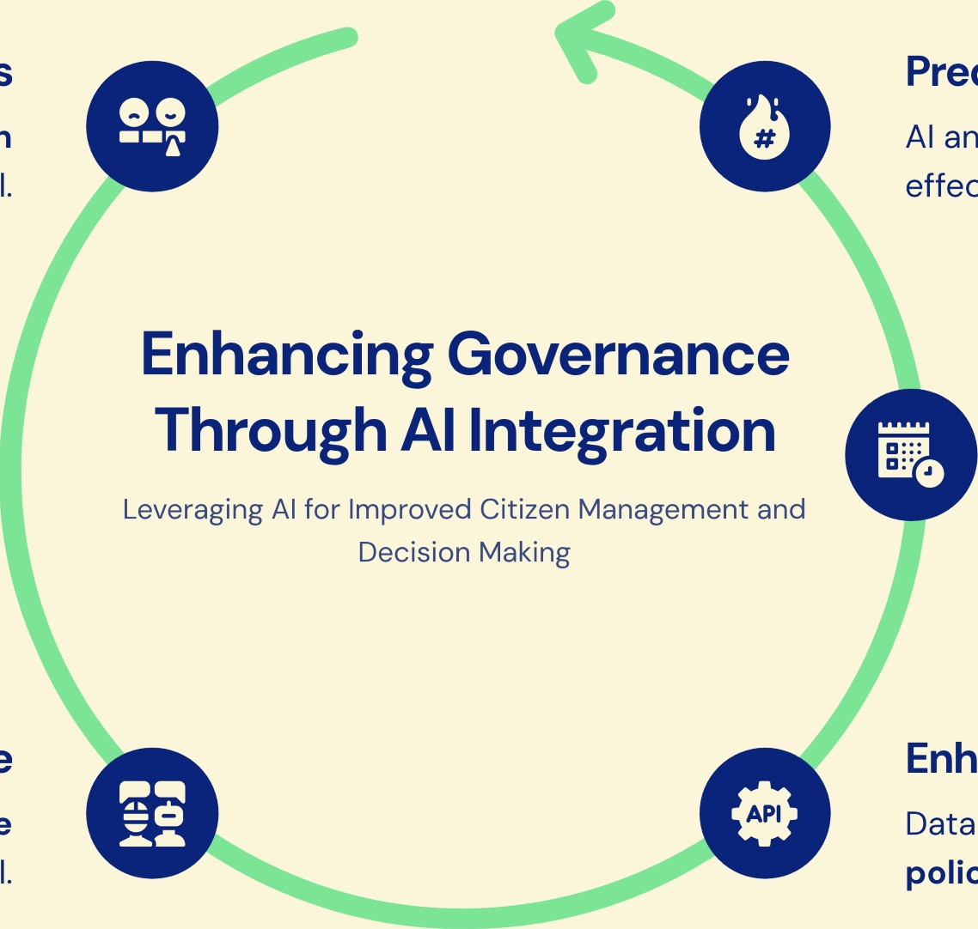Citizen Expectations

Aligning decisions with citizen expectations is crucial.

Effective Governance

Al leads to more effective governance overall.

### Predict Trends

Al analytics forecast citizen needs effectively.

### Allocate Resources

Al optimises resource distribution per demand.

### Enhance Policy

Data-driven insights inform better policy-making.

## Addressing Obstacles in Deployment

Navigating the complexities of Al implementation in government systems

Data SecurityIntegration Issues

|  |  |  |
| --- | --- | --- |
| |  | | --- | | 1 | |  |
| |  | | --- | | 4 | |

Protecting sensitive citizen data is2 Ensuring compatibility with existing systems paramount.can be complex.

Mitigation StrategiesPublic Trust

Transparency and engagement can mitigate3 Building confidence in Al systems is crucial these challenges.for their acceptance.

## Ethical Considerations for Management

Exploring the essential ethical standards and data privacy measures in Al governance.

Al Algorithm Bias

Ensuring fairness in Al decision-making processes is crucial to prevent discrimination and uphold justice.

Data Privacy Rights

Adhering to regulations like GDPR guarantees the protection of citizen information and their privacy rights.

Transparency in Al

Clearly communicating how Al impacts citizen interactions fosters understanding and builds trust in technology.

Building Trust

Maintaining ethical standards in Al use fosters trust among citizens and encourages engagement with governance.

Accountability Measures

Implementing accountability measures in Al systems ensures responsible use and addresses potential misuse of data.

Ethical Standards

Establishing robust ethical guidelines protects citizens' rights and promotes responsible Al development.

Emerging Trends in Solutions

Exploring the future of Citizen Al with a focus on personalisation, analytics, and collaboration

Increased Personalisation of Services

Tailoring services to meet the unique needs of individual citizens will enhance user satisfaction and engagement in governance processes.

Utilisation of Real-time Analytics

Governments will harness Al technologies to provide instant data insights, enabling them to respond swiftly to citizen needs and issues as they arise.

Development of Collaborative Platforms

New tools will facilitate greater citizen participation in governance, ensuring that the voices of the public are heard and considered in decision-making processes.

Shift Towards Dynamic Governance Models

The integration of these technologies signifies a move towards more adaptable and responsive governance frameworks that can evolve with citizen needs.

Focus on Inclusivity in Solutions

Future Citizen Al solutions will emphasise inclusivity, ensuring all demographics are represented and catered for in civic engagement initiatives.

## Enhancing Public Services with Al

Utilising Al to streamline, enhance, and improve accessibility in public services

Streamlining Processes Automating service requests and feedback collection.

Enhancing Accessibility Ensuring services are available to all citizens.

Improving Communication

Providing timely updates through Al tools.

Efficient Service Delivery

Creating a more effective delivery model.

Equitable Access

Services for all backgrounds.

Citizen Engagement Increased involvement in service processes.

|  |
| --- |
| Enhancing Governance Through Real-time Feedback with Citizen Al  Utilising instant surveys, social media monitoring, and adaptive policies for improved citizen engagement and satisfaction |

Instant Surveys

Instant Surveys allow governments to gather citizen opinions immediately following service interactions, ensuring that feedback is captured while experiences are still fresh in the mind of the citizen.

Social Media Monitoring

Social Media Monitoring involves analysing public sentiment and feedback through social platforms, enabling authorities to understand citizen perspectives and address concerns promptly.

Adaptive Policies

Adaptive Policies enable quick adjustments to governance strategies based on real-time citizen inputs, fostering a responsive and flexible approach to policymaking.

Feedback Loop

Creating a Feedback Loop enhances citizen engagement and satisfaction by continuously incorporating citizen feedback into decision-making processes, leading to more effective governance.

## Harnessing Citizen Al for Community Empowerment

Leveraging Al to foster civic engagement and transparency in local governance.

Facilitating Community Projects Identifying local needs and resources.

Enhancing Civic Participation Engaging citizens in decision-making.

Promoting Transparency Access to information on governance.

Key Metrics for Assessing Citizen Al Success

Essential metrics to evaluate the effectiveness of Citizen Al initiatives and citizen engagement

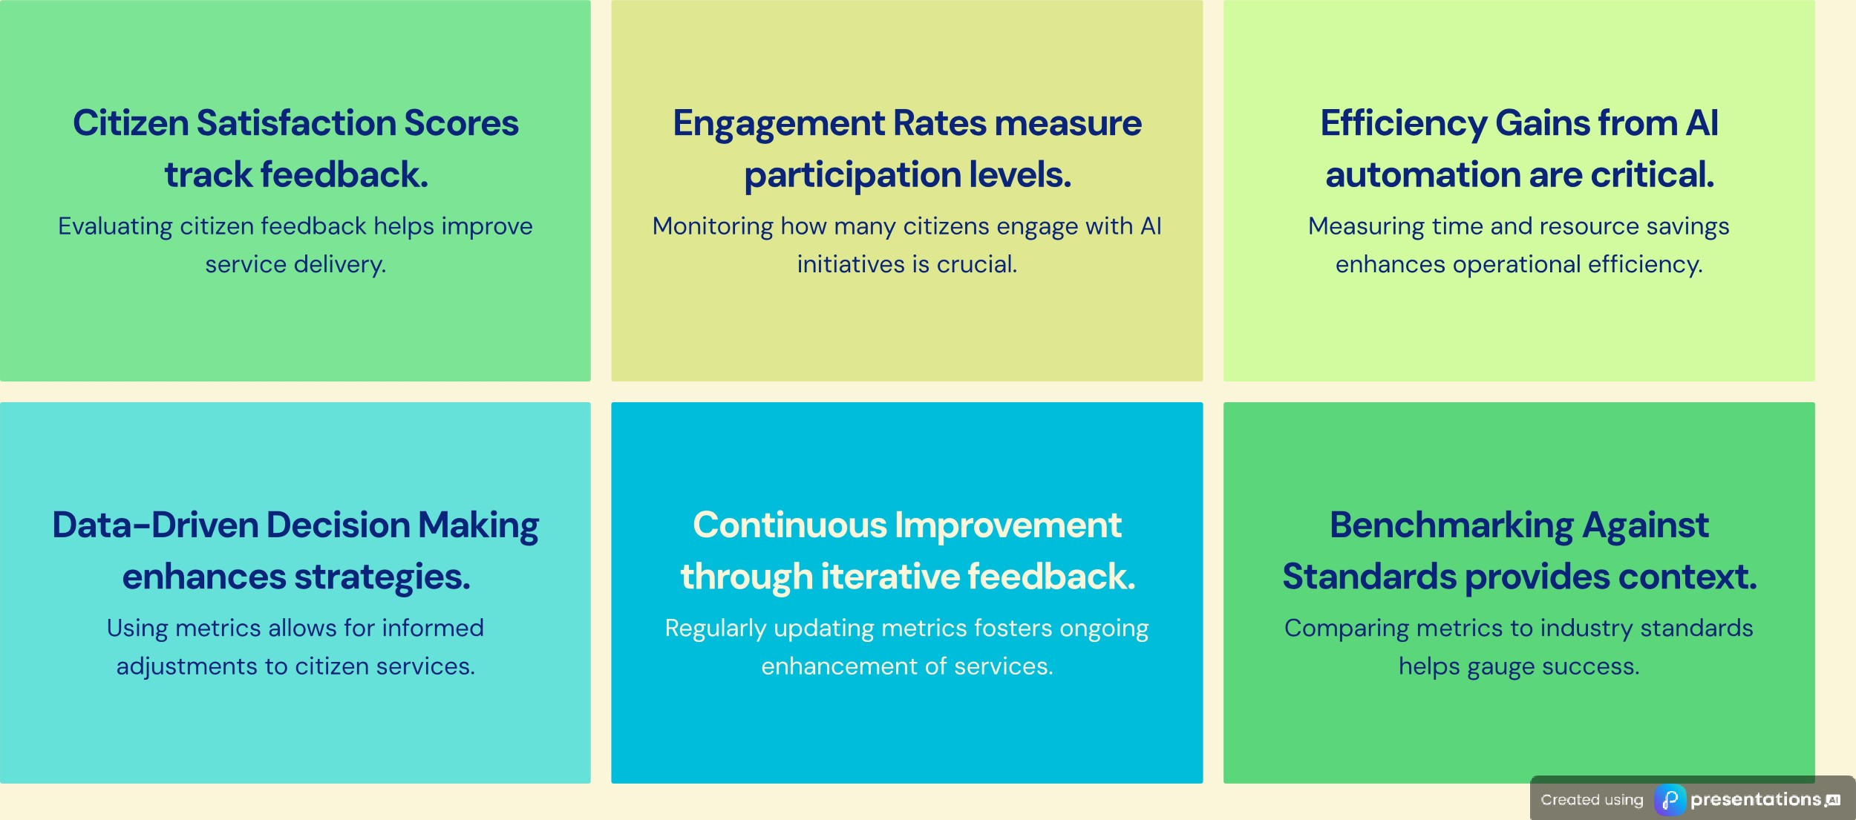

Transforming Citizen

# Engagement with Al

The integration of Citizen Al into governance is revolutionising how governments connect with their citizens. By employing advanced Al technologies, public services can be enhanced significantly, leading to improved service delivery and a more inclusive decision-making process. This transformation not only fosters better engagement but also ensures that citizens feel valued and heard. As we look ahead, the future of citizen management is promising, with Al playing a pivotal role in shaping a more connected and responsive government.